Docstrings in python
Python docstrings are the string literals that appear right after the definition of a function, method, class, or module.
Example
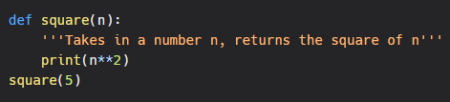
Here,
'''Takes in a number n, returns the square of n''' is a docstring which will not appear in output
Output:
25
Here is another example:
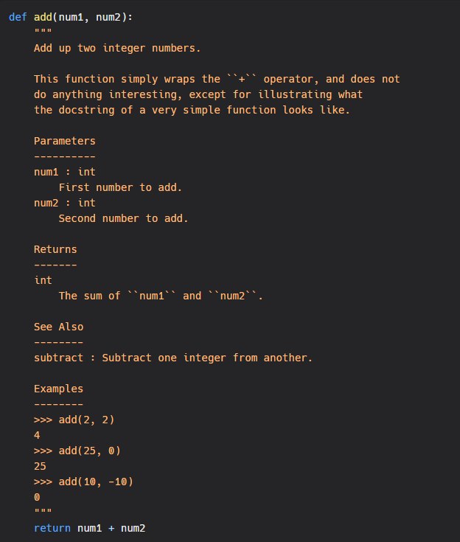
Python Comments vs Docstrings
Python Comments
Comments are descriptions that help programmers better understand the intent and functionality of the program. They are completely ignored by the Python interpreter.
Python docstrings
As mentioned above, Python docstrings are strings used right after the definition of a function, method, class, or module (like in Example 1). They are used to document our code.
We can access these docstrings using the doc attribute.
Python doc attribute
Whenever string literals are present just after the definition of a function, module, class or method, they are associated with the object as their doc attribute. We can later use this attribute to retrieve this docstring.
Example
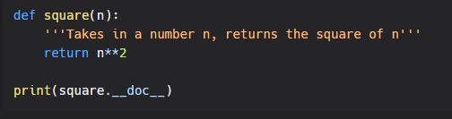
Output:
Takes in a number n, returns the square of n

PEP 8
PEP 8 is a document that provides guidelines and best practices on how to write Python code. It was written in 2001 by Guido van Rossum, Barry Warsaw, and Nick Coghlan. The primary focus of PEP 8 is to improve the readability and consistency of Python code.
PEP stands for Python Enhancement Proposal, and there are several of them. A PEP is a document that describes new features proposed for Python and documents aspects of Python, like design and style, for the community.
The Zen of Python
Long time Pythoneer Tim Peters succinctly channels the BDFL’s guiding principles for Python’s design into 20 aphorisms, only 19 of which have been written down.
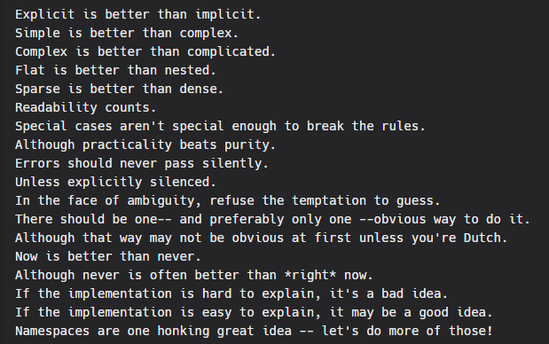Easter egg
import this

